MINIMIZE THE ELECTRICITY COST

IN A

WATER TREATMENT PLANT

BY
H.D.FERNANDO (S/13/809)
S.PURUSANTH(S/13/832)
M.H.M.JAYASINGHE(S/13/850)

MT 410 Optimization for Engineering Design
Statistics and Operational Research
UNIVERSITY OF PERADENIYA

ACKNOWLEDGEMENT

We express our deep sense of gratitude to our supervisor, Dr. Z. A. M. S. Juman, Department of Mathematics, Faculty of Science, University of Peradeniya for encouraging us to do a successful research and providing us useful advices throughout the project.
Wealso express our gratitude to our colleagues and our family members for their kind support during our program of study.

TABLE OF CONTENTS

ACKNOWLEDGEMENT …………………………………………………………………………………………2
ABSTRACT …………………………………………………………………………………………………………..4
CHAPTER 1 : INTRODUCTION ………………………………………………………………………………5
  - Introduction to Operation Research
  - Introduction to engineering design
CHAPTER 2 : METHODOLOGY ……………………………………………………………………………8
2.1 Problem Identification
  - Constructing the model
2.2.1 Objective function
2.2.2 Constraints
2.2.3 Model to optimize the pump operation
CHAPTER 3 : ASSUMPTIONS……………………………………………………………………………24
CHAPTER 4 : CONCLUSION……………………………………………………………………………..26
REFERENCES …………………………………………………………………………………………………..28

ABSTRACT

CHAPTER 1 : INTRODUCTION
  - Introduction to Operations Research
Operations Research (OR) is a discipline that deals with the application of advanced analytical method of problem-solving and decision-making that is useful in the management of organization. In OR, problems are broken down into basic components and then solved in defined steps by mathematical analysis.
Analytical methods used in OR include mathematical logic, simulation, network analysis, queuing theory, game theory.

OR applications were originated in military efforts before World War II. Its techniques have now grown to concern problems in a variety of industries. Today, OR is a well-developed field with a set of modern solving techniques which are used to decision-making in many real world problems.

OR is often considered to be a sub field of mathematics. Employing techniques from other mathematical sciences, such as mathematical modeling, statistical analysis, and mathematical optimization, OR arrives at optimal or near-optimal solutions to complex decision-making problems. This field is often concerned with determining the maximum (of profit, performance or yield) or minimum (of loss, risk or cost) of some real world objective.

Flow chart showing the stages in Operation Research

Problem Definition
Model Construction

Input Data Acquisition
Solution Derivation

Testing of model and solution
Implementation of Results
Analyzing Results/Establishment of control

  - Introduction to Engineering Design

Engineering Optimization is the subject which uses optimization techniques to achieve design goals in engineering. It is sometimes referred to as design optimization.Optimization algorithms are becoming increasingly popular in Engineering design activities. For example optimization algorithms are used in aerospace design to minimize the overall weight of the aircraft. Mechanical engineers design mechanical components for the purpose of achieving either a minimum manufacturing cost or maximum component life. Production engineers are interested in designing optimum schedules of various machine operators to minimize the idle time of machines and the overall machine completion time. Civil engineers are involved in designing buildings, bridges, dams and other structures in order to achieve a minimum overall cost or maximum safety and electrical engineers are interested in designing communication networks so as to achieve minimum time for communication from one node to another.

CHAPTER 2 : METHODOLOGY
2.1 Problem Identification
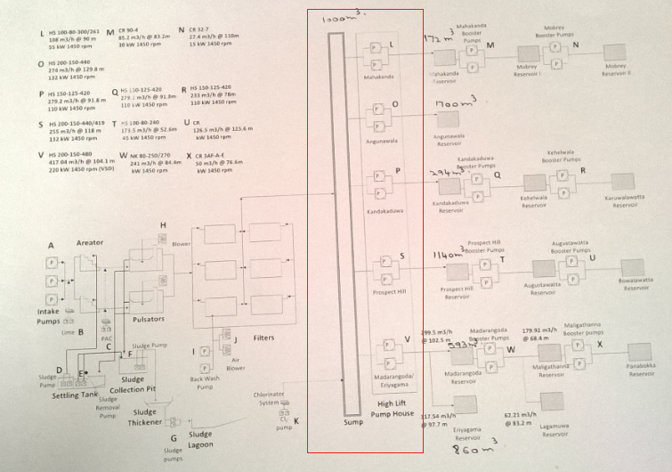

We analyzed the electricity power consumption of each unit in the water plant. Then we came up with a conclusion that the power consumption of the unit which is pointed out by the rectangle in the above figure was higher than the other units in the water plant, also this was the only unit in the plant where the power consumption can be adjusted. This unit consists of ten water pumps and they are allocated to the pump houses L,O,P,S and V as shown in the above figure. Each pump house is used to pump water to the reservoirs which are located in A, B, C, D, E/F . Though there are two pumps at each pump house only one machine is used at a time to pump water whereas the other pump is kept to use in case of a failure of the first machine. Water stocked at the above mentioned reservoirs are again distributed among reservoirs which are connected to them according to the demand of the customers. The demand of the customers varies with respect to the time .The records available at the water plant shows that from 6.00pm-10.00pm there is an excess demand for water. Thus 4 hours start from6.00 pm are known as peak hours whereas the remaining hours are off peak hours. Since the electricity consumption for the plant doesn’t depend on peak and off peak hours, each hour is considered as similarity hours.
The process time of the water pumps depend on the water level of the respective reservoirswhich they are pumping water into. The highest level that the water can be pumped into a reservoir is known as “High Level” whereas the lowest level is “Low Level” .Once water reaches High Level of a reservoir the corresponding pump automatically stops its process and waits until the level is decreased into Low Level to start its proceedings again.

The following table represents the speed, energy consumption, rpm (rotations per minute) of the pumps at each pump house and the capacities of the corresponding reservoirs.
Table 1

Pump House | Speed ($m^{3}/h)$ | Efficiency(KW) | Rpm | Capacity($m^{3}$)
L | 108 | 55 | 1450 | 172
O | 274 | 132 | 1450 | 1700
P | 279.2 | 110 | 1450 | 294
S | 255 | 132 | 1450 | 1140
V | 417.04 | 220 | 1450 | Second reservoir 860
 |  |  |  | First reservoir 593

2.2 Constructing the Model
2.2.1 Objective Function

Since our objective is to minimize the total electricity cost of the pumping unit we need to minimize the number of power units (KWh) use by each pump house. The daily power consumption of a particular pump house for a given day can be calculated as follows.
Power consumption per hour*Total hours the pump house works per day

Thus the total power consumption of the all 5 pump houses can be given as follows
$\sum_{i=1}^{5}{Power consumption of the i th pump house per hour*}Total hours i th pump house works per day$

According to the table 1 the power consumption of each of the pump house is a constant value. Thus in order to minimize the daily electricity cost we need to find the minimum number of hours that each of the pump houses functions while satisfying the customer demand. When analyzing the process of the unit we came at a conclusion that if we could determine the minimum time that each of the pump house functions in each hour for a day, then we can minimize the total power consumption of the unit. Thus we decided to choose the variables for our model as follows
X _{Li}=time that the pump house L need to process in the i^{th} hour.
X _{Oi}= time that the pump house O need to process in the i^{th} hour.
X _{Pi}= time that the pump house P need to process in the i^{th} hour.
X _{Si}= time that the pump house S need to process in the i^{th} hour.
X_{Vi}= time that the pump house V need to process in the i^{th} hour.
i =1 - 24

As an example expression for the pump house L to minimize its electricity cost will be as follows
Min Z_{L}= 55*(xl1+xl2+xl3+xl4+xl5+xl6+xl7+xl8+xl9+xl10+xl11+xl12+xl13+xl14+xl15+ xl16+xl17+xl18+xl19+xl20+xl21+xl22+xl23+xl24)
Our objective is to minimize the total electricity cost of the pumping unit as a whole; also we could not find any relationship among the pump houses. Thus the objective function can be formulated as follows

MinZ=55*$\sum_{i=1}^{24}{X(Li})$+132*$\sum_{i=1}^{24}{X(Oi)}$+110*$\sum_{i=1}^{24}{X(Pi)}$+132*$\sum_{i=1}^{24}{X(Si)}$+220*$\sum_{i=1}^{24}{X(Vi)}$

2.2.2 Constraints

Constraints for the daily water demand

Each of the reservoirs should satisfy the customer demand in that area .Thus in order to satisfy the required demand the plant should pump the water amount which is required. The water amount (m³) that pumps from a given pump house on daily basis can calculated as follows.
Volume (m³) = Speed of the pump* Total hours the pump house works per day
Volume (m³) = Speed of the pump* Total hours the pump house works per day

Since in our problem we consider the time that each pump house should processing each hour for a given day while satisfying the customer demand. Thus the water amount that can be pumped by a particular pump house is given by the following equation.
Volume (m³) = Speed of the pump*$\sum_{i=1}^{24}{Time the pump house functions in the i th hour}$

For an example let’s consider the water amount pumped by the pump house L
Volume (m³) =108$\sum_{i=1}^{24}{X(Li)}$

The required demand of each area is available at the water plant. Each of the pump houses should pump the least amount required by the customers to a particular area .so the constraint for the customer demand for the pump house L can be formulated as follows.
108 $\sum_{i=1}^{24}{ X(Li)}≥$880

Thus the demand constraints for the all 5 pump houses can be formulated as follows

108 $\sum_{i=1}^{24}{ X\left(Li\right)≥580}$ (Pump house L)
274 $\sum_{i=1 }^{24}{X(Oi)}≥5566$ (pump house O)
279.2$\sum_{i=1}^{24}{ X(Pi)}≥4870$(pump house P)
255 $\sum_{i=1}^{24}{ X(Si)}≥3711$ (pump house S)
417.04 $\sum_{i=1}^{24}{ X(Vi)}≥7262$ (pump house V)

Constraint for the Pump Operating Time

The maximum time that each pump house can be operated in each hour is 1 hour. Thus we can formulated time constraints for each of the pump house as follows

X _{Li}$≤1$ (pump house L)
X _{Oi}$≤1$ (pump house O)
X _{Pi}$≤1$ (pump house P)
X _{Si} $≤1$ (pump house S)
X_{Vi}$≤1$ (pump house V)

i=1 - 24

Constraint for the Tank Level

In our experiment we need to determine the time that each pump house needs to function in each hour for a given day. This time depends with the pump switch on time and switch off time. The above mentioned times depend on the level of the reservoir.
When analyzing the data available at the water plant we noticed that the following data are available
- L_{i}=Tank level at each hour(m)
- X_{i}=process time of each pump house in the I th hour (min)
- V =volume of each tank(m³)
- H =Height of each tank(m)
- UB=“High Level” of each tank (m)
- LB=“Low Level” of each tank (m)
- S =Speed of the pump(m³h⁻¹)

Followings are the terms which we can obtain from the above mentioned data
- V_{i}=volume of the tank in the i th hour. (m³)
- C_{i}=decrement or increment of the water Volume in the i th hour with respect to the (i-1) th hour(m³)
- S_{i}= volume pump by a pump house in the i th hour(m³)
- Di=demand of customer in i th hour (m³)

The raw data which we obtained for the pump house L is as follows

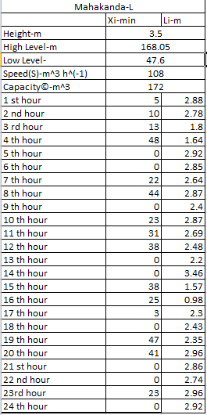

Though it is necessary to know the customer demand at each hour that should be satisfied by the respective pump houses, we could only find the daily demand from the data available at the plant .Therefore in order to calculate the hourly demand of the customers at each pump house we developed equations which can be used in different conditions.
- Case 1
If water level If water level increases in the (i+1)^{th} hour with respect to the (i)^{th} hour
(I.e. V_{i+1}>V_{i} => C_{i+1}=V_{i+1}-V_{i})

D_{i}=S_{i}-C_{i+1}

- Case 2
If water level If water level decreases in the (i+1) ^{th} hour with respect to the (i) ^{th} hour
(i.e V_{i+1}<V_{i} => C_{i+1}=V_{i}-V_{i+1})

D_{i}=S_{i}+C_{i+1}

- Case 3
If the water level does not change in the i th hour with respect to the (i-1) th hour.

D_{i}=S_{i}

D_{i}=S_{i}

Then we developed an equation which will be useful to calculate the water volume of a tank in a given hour when the data for demand in each hour is given.

V_{i+1} = V_{i} + (S_{i} – D_{i})

At the beginning of a particular day we need to determine whether a selected pump house is functioning or not. As we are unable to determine it directly we assume that the water level might be at its “High Level” or “low level” at the beginning of a particular day In order to develop the following process .This process can be used to check whether a pump house functions in a particular hour.

Case1:

If L_{i} = LB the switch will on in the i ^{th} hour and functions until L_{i} reaches the LB again or UB of the tank.

Case 2:

If L_{i} = UB the switch will off in the i ^{th} hour and remains same until L_{i} reaches the UB again or LB of the tank.

When analyzing L_{i} to determine whether the pump processes or not, in real world situation the tank level neither at its UB nor LB .Thus with the use of the V_{i} (volume in the i^{th} hour) we determine the hours that a given pump need to process. By analyzing the values we obtained for V_{i} we decided the maximum volume (UB) and the minimum volume (LB) for a particular tank. Then we checked whether a machine is functioning in a given hour.

The following table represents the information that we obtained for the pump house L with the use of the raw data.
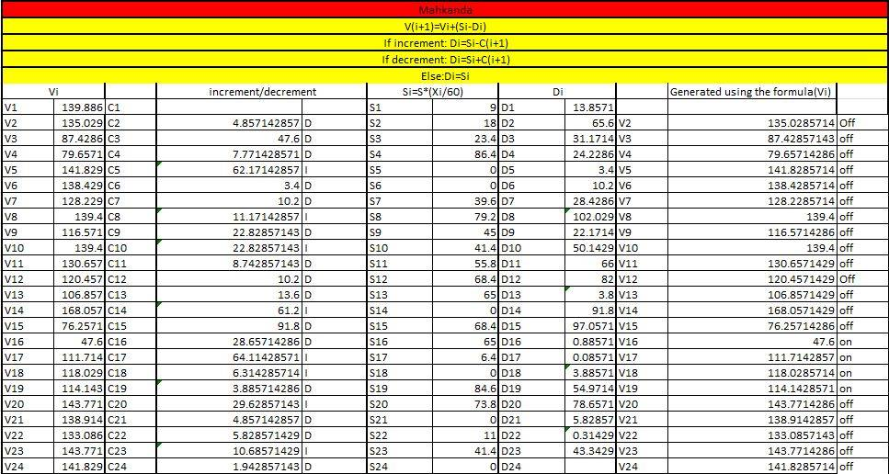

The above mentioned cases and equations are valid for the pump houses L, O, P, S only as they are pumping water for a one reservoir only .Though it is so pump house V is used to pump water to two reservoirs E and F. The following figure represents the process that takes place in the pump house L.

F Reservoir

L

E Reservoir

According to the Chief Engineer of the water plant the pump house L gives priority to fulfill the water amount required by the F reservoir as it is connected to three more reservoirs. Once the “High Level” of the F reservoir is reached then the pump house L shifts to fulfill the water amount required by the E reservoir.

In order to calculate the hourly demand of the customers at this pump house we need to develop new equations which can be used in different conditions since this pump house is different from the other pump houses.
- Case 1
If water level increases in both tanks in the (i+1) ^{th} hour with respect to the (i) ^{th} hour

D_{i}=S_{i}-C1_{i+1}-C2_{i+1}

- Case 2
If water level If water level decreases in both tanks in the (i+1) ^{th} hour with respect to the (i) ^{th} hour

D_{i}=S_{i}+C1_{i+1}+C2_{i+1}

- Case 3
If water level increases in first tank and decreases in second tank in the (i+1) ^{th} hour with respect to the (i) ^{th} hour

D_{i}=S_{i}-C1_{i+1}+C2_{i+1}

- Case 4
If water level decreases in first tank and increases in second tank in the (i+1) ^{th} hour with respect to the (i) ^{th} hour

D_{i}=S_{i}+C1_{i+1}+C2_{i+1}

- Case 5
If the water level does not change in both tanks in the i th hour with respect to the (i-1) th hour.

D_{i}=S_{i}

Though it is necessary to develop new equation to calculate demand in each hour for the pump house V, we can use all the other equations which we derived for other pump houses to find Si,Vi and pump switch on and off times.

Constraints Obtained

According to the table 2 pump house L should process in 16th, 17th, 18th, 19thhours of a particular day to satisfy the daily customer demand. Thus the tank level constraint for the pump house L can be formulated as follows
X_{L16} + X_{L17} + X_{L18} + X_{L19} =4;

The maximum time that the machine can perform in any of the selected hour is one hour .Thus according to the data we obtained the machine L should perform 4 hours.

The constraints for the all other pump houses also can be formulated as follows with the use of the method mentioned above.
X_{O1}+X_{O2}+X_{O3}+X_{O4}+X₀₅+X_{O6}+X_{O20}+X_{O21}+X_{O22}+X_{O23}+X_{O24 =}11 (B reservoir)
X_{P1}+X_{P2}+X_{P3}+X_{P16}+X_{P17}+X_{P18}+X_{P19}+X_{P20}+X_{P21}+X_{P22}+X_{P23}+X_{P24}=12 (C reservoir)

X_{S1}+X_{S2}+X_{S3}+X_{S4}+X_{S5}+X_{S6}+X_{S7}+X_{S8}+X_{S9}+X_{S10}+X_{S11}+X_{S12}+X_{s13}+X_{S14}=14 (D reservoir)

X_{V1}+X_{V2}+X_{V3}+X_{V4}+X_{V15}+X_{V16}+X_{V17}+X_{V18}+X_{V19}+X_{V20}+X_{V21}+X_{V22}+X_{V23}=13
(E reservoir/F reservoir)

i = 1 – 24

2.2.3Model to Optimize the Pump Operations in a Water Treatment Plant

Min Z= 55*$\sum_{i=1}^{24}{X(Li})$ + 132*$\sum_{i=1}^{24}{X(Oi)}$ + 110*$\sum_{i=1}^{24}{X(Pi)}$ + 132*$\sum_{i=1}^{24}{X(Si)}$ +220*$\sum_{i=1}^{24}{X(Vi)}$

Subject to:
108*$\sum_{i=1}^{24}{X\left(Li\right) ≥880}$ (Pump house L)
274*$\sum_{i=1}^{24}{X\left(Oi\right)} ≥6397$ (pump house O)
279.2*$\sum_{i=1}^{24}{X(Pi)} ≥5204$ (pump house P)
255*$\sum_{i=1}^{24}{X(Si)} ≥3752$ (pump house S)
417.04*$\sum_{i=1}^{24}{X(Vi)}≥5655$ (pump house V)

X _{Li}$≤1$ (pump house L)
X _{Oi}$≤1$ (pump house O)
X _{Pi}$≤1$ (pump house P)
X _{Si} $≤1$ (pump house S)
X _{Vi}$≤1$ (pump house V)
X_{L16} + X_{L17} + X_{L18} + X_{L19} =4 (A)
X_{O1}+X_{O2}+X_{O3}+X_{O4}+X₀₅+X_{O6}+X_{O20}+X_{O21}+X_{O22}+X_{O23}+X_{O24 =}11 (B)
X_{P1}+X_{P2}+X_{P3}+X_{P16}+X_{P17}+X_{P18}+X_{P19}+X_{P20}+X_{P21}+X_{P22}+X_{P23}+X_{P24}=12 (C)

X_{S1}+X_{S2}+X_{S3}+X_{S4}+X_{S5}+X_{S6}+X_{S7}+X_{S8}+X_{S9}+X_{S10}+X_{S11}+X_{S12}+X_{s13}+X_{S14}=14 (D)

X_{V1}+X_{V2}+X_{V3}+X_{V4}+X_{V15}+X_{V16}+X_{V17}+X_{V18}+X_{V19}+X_{V20}+X_{V21}+X_{V22}+X_{V23}=13 (E/F)

i = 1 – 24

CHAPTER 3 : ASSUMPTIONS

- Consider only the first tank

In this plant water is purified and send to 5 storage reservoirs in 5 different areas (A, B, C, D, E/F ). If we consider about A tank there are two other tanks which are fed from A tank. All the other 4 mother tanks also have child tanks in respective areas. In our model we consider only about the five mother reservoirs.

- Houses have storage tanks

We develop this model by considering the mean consumptions of each area. So in practical applications, there will be some issues in adequate water supply. As example in holiday’s water consumption demand may be high. So we do not consider about that and assumed that every house has a storage tank, if water supply is not continuous or not enough for the consumption people should use small storage tanks.

- No electricity failure or machinery failure

For the development of the model we used past water consumption in a week. When getting the data, we neglected the days where power failures or machinery failures happened.
So in practical applications this model is not suitable for occasion where machinery or electricity failures occurred in the plant.

- Consider a mean demand

When we analyzing the data for the demand we came to know that there was a deviation for customer demand in each identical hour in seven days .Thus we consider a mean value for customer demand in each identical hour

CHAPTER 4 : CONCLUSION

When analyzing the raw data we noticed that a given pump house does not process continuously .Though it is so the solution of our model shows that a pump house can perform continuously several hours which will help the plant to achieve its main objective of minimizing the energy consumption.


- Efficiency of the pump houses will increase

As a pump functions several hours continuously the machine can achieve its full speed and perform well and it will results in low energy consumption. Though it is so according to the data we obtained from the plant the machines do not perform continuously .Thus the machine could not perform at its full efficiency level which will results in higher energy consumption.

Initially kinetic energy should be given by the pump to break the inertia of water to flow and if the machine does not perform continuously the energy should be given at each time the machine starts processing. But from our solution we obtain we can continue with the kinetic energy given at beginning.

- Lifespan of a machine will increase

When machine repeatedly switch on and off in regular time intervals the lifetime of the machine will reduce .As our model gives a solution for this issue the life time of machines will increase .

- No water wastage

As we consider about the water level of the reservoir when constructing our model the plant can supply the exact water amount required by the customers Due to the above reason there is no water wastage.

REFERENCES

